

**USER MANUAL**

**QCY T1**

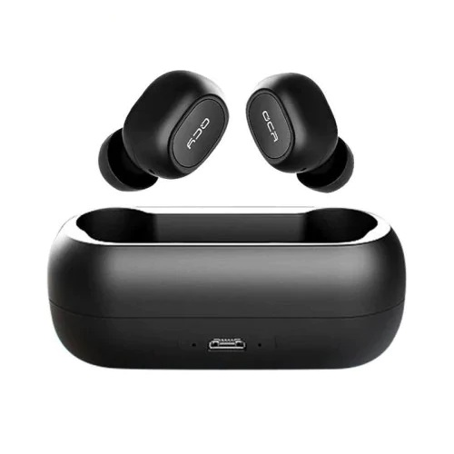

**Table of Contents**

Overview: 3

How to pair: 4

Functions: 5

Product Parameter: 8

Tips: 9

Caveats: 9

Warranty Card: 10

# **Overview:**

Choose ear tips:

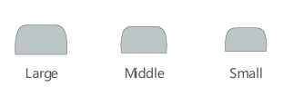

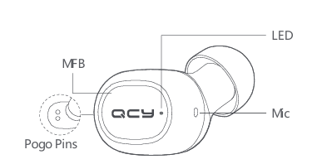

It is recommended you try middle Ear Tips first they fit most people.

For first time pairing:

Take out both two Ear Buds then re-insert them into the case to activate the earphones.

# **How to pair:**

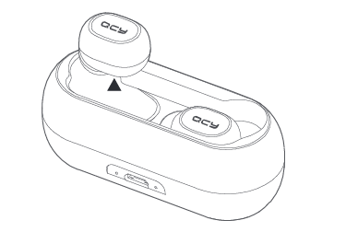

Push both Ear Buds into charging case to activate them then take out from the case and they will auto power on and pair with each other. Right Ear Bud will auto enter pairing mode when LED on left Ear Bud turns off. On cell phone, search for QCY-T1 and tap to connect cell phone to both Ear Buds.

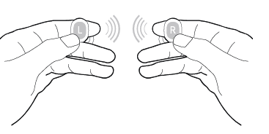

# **Functions:**

Power-on:

Method 1: take earphones out from the charging case and they will auto power on (LED glows solid white).

Method2: power off earphones and hold MFB for 1s to power on (LED glows solid white).

Power-off:

Hold MFB for 3s (red LED will turn on for 2s).

Ignore Call:

Hold MFB for 1s to ignore incoming call.

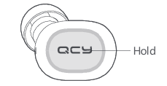

Answer Call:

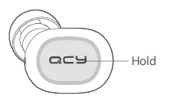Tap MFB to answer incoming call and tap again to end it.

Switch Audio Output:

When calling, hold MFB for 1s to switch audio output between cellphone and earphones.



Mute-on/off:

When calling, double tap MFB to switch mute on/off

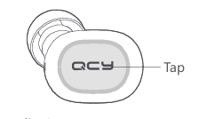

Playback/pause:

When standby in stereo mode, tap MFB to play and tap again to pause.



Skip Track Forward/backward:

When playing, double press MFB on right/left Ear Bud to skip track forward/backward.

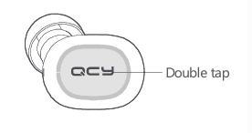

Voice Assistant:

When standby, hold MFB for 1s to activate voice assistant (like Siri).



Charge the Earphones:

Insert the earphones into charging case (pogo pins should be well-contacted). LED will be solid red when charging and turn to white for 60s once topped up.

Charge the Case:

LED glows solid green when the case is being charged and turn off once topped up. Please charge the case via USB cable.

# **Product Parameter:**

Product Parameter Model: T1

Operation Range: 10m (with no obstacle)

Bluetooth version: V5.0

Charging time: approx. 2hr

Standby time: approx. 120hr Music time: approx. 4hr

Battery type: li-ion

Bluetooth profiles: HFP/HSP/A2DP/AVRCP

Battery capacity (earphones): 3.7V 43mAh

Battery capacity (charging case): 3.7V 380mAh

Input parameter (charging case): 5V 500mA

(All technical data shall be subject to practical performance.)

# **Tips:**

1. Before using the headset, please read the manual carefully and keep it for future references.

2. The headset need to be fully charged prior to first-time use. 3. If the headset is left unused for over two weeks, please recharge it periodically.

4. Please use the chargers made by qualified manufacturer.

5. If the headset cannot be found by your phone, please check whether it is in pairing mode; if left unconnected for a long while, the headset will exit pairing mode, please re-enter the mode; if a procedure error of your phone occurs, reboot it; a procedure error of the headset occurs, reboot or reset it.

# **Caveats:**

1. Never disassemble or modify your headset for any reasons to avoid any damages and danger.

2. Do not store the headset in extreme temperatures (under 0℃ or over 45℃).

3. Avoid using the indicator close to the eyes of children or animals.

4. Do not use this headset during a thunderstorm to avoid irregular function and increased risk of electric shock.

5. Do not use harsh chemicals or strong detergents to clean the headset.

# **Warranty Card:**

Warranty Period 12months after you purchase this item. (or you may inquire your local shopper for more details.) Free Service: Supposing any defects caused by quality issues occur within the warranty period, please take this warranty card and purchase receipts to your distributor for free.

|  |  |
| --- | --- |
| Model Number: |  |
| Date of Purchasing: |  |
| User's Name: |  |
| User's Phone: |  |
| User's Address: |  |
| Shop's Name: |  |
| Shop's Address: |  |
| Comments: |  |